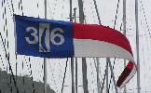
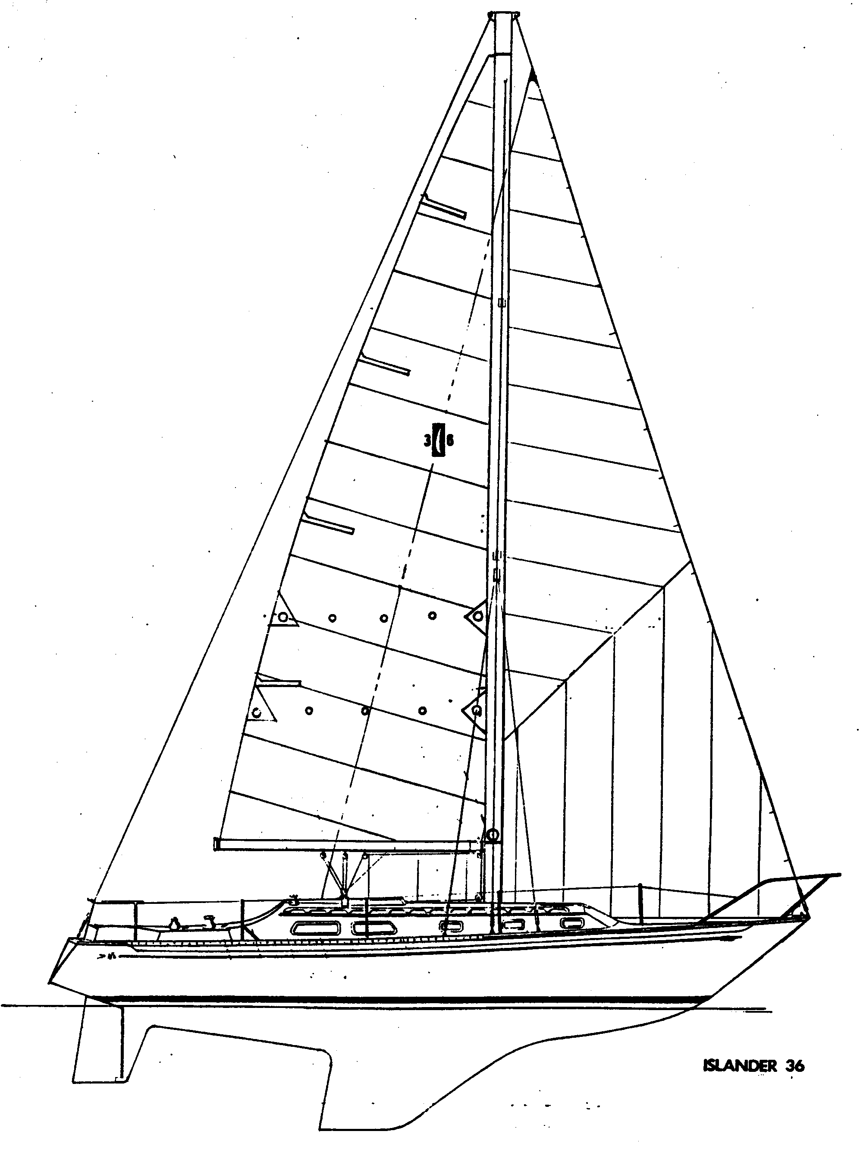
Islander 36
Living the life at 50

Fifty years ago, in 1970, the Islander 36 was conceived as a remarkable racer/cruiser with a state-of-the-art interior, great good looks and great performance. That 770 were produced and the majority are still sailing today from harbors around the world, proves the point. It flourished because of its genuine sailing attributes, its success in racing, and the establishment of the I-36 Association on San Francisco Bay. All of these showcased the Islander 36. Establishing a web site in 1998 provided Islander owners around the country, and eventually around the world, a forum to share knowledge and support each other.

From the trials and tribulations of building a one-design fleet on San Francisco Bay, to the 2009 circumnavigation of the globe by Zac Sunderland in an I-36 at the age of 17, and on to the present, it’s a warm story of sailors doing what we love. Here’s a look at some highlights along the way.

In January 1970 Ken Smith, President, hired Charlie Underwood to be the Chief Engineer and VP of Manufacturing of Islander Yachts. As he noted, “The I-36 was the first to be built on his watch. The design had already been completed by Naval Architect Alan Gurney and the interior layout and deck were designed by local Industrial Designer, Joe Artese. At the time Alan’s architectural services were in demand because his boats, including “Windward Passage”, were winning races. Joe, a very creative stylist, had previously worked in Engineering at Columbia Yachts. Both Alan and Joe had been commissioned by Ken Smith.

While it is relatively common today to team industrial designers with Naval Architects and Production Engineers in designing and developing new models, in 1971 it was a rare occurrence. The Islander 36 hit its target market dead center as a competitive racer, a comfortable cruising boat with a state-of-the-art interior and attractively priced. Joe’s outstanding I36 interior would continue to influence Islander’s interior design for years to come.”

Building boats is one thing. Getting them sold is another. Don Wilson, then in his 20s, first tried to contact Ken Smith to promote an I-36, and though rejected twice, became the first I-36 dealer on San Francisco Bay and eventually sold about 150 boats!

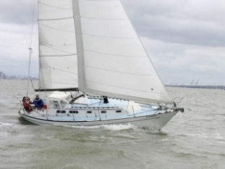
Lou and Diane Zevanov were the first buyers of an Islander 36 on the Bay, naming her Diana. Lou had several conversations with Alan Gurney when the boat was in production. Gurney stated that the boat was basically designed for conditions found on the Bay. The boat tracks very well under spinnaker because the fin keel and skeg mounted rudder make it possible to surf down waves in a blow with your hands barely touching the wheel.

On 17th November 1973, Lou met with several new owners of the I36 at Coyote Point YC. Wayne Hallenbeck, owner of {Nebbia ,Williwa (now Palau)} was elected the first commodore of the I36 Association of San Francisco Bay. This gave the organization the legitimacy to compete in the SFO Bay “one Design” of the Yacht Racing Association.

OK, so now there was an Islander 36 Association, but one-design rules were needed. Working with renowned SF sailor, designer, builder and IOR rule measurer Myron Spaulding helped bring the fleet into one-design status. Rig dimensions were pretty straight forward with the class agreeing on the “standard” or shorter mast as the Bay standard. However Islander also offered a “tall” rig for owners sailing in lighter wind areas like southern California, and that would eventually become an issue. Another quirk in the early measuring was that somehow the original mould for the keel turned out to be asymmetric! The class rules then required that the keel NOT be modified in the interest of “cost and fleet standardization.” A set of templates was used to check if the keel had been faired and a number of protests ensued over the years. Then throw in a boat with a tapered mast. Gary Mull provided text and drawings for “an 8 foot long PVC pipe weighing 85 ounces (lead shot) with the center of gravity 32 inches below the top of the spar which would effectively remove any advantages.”

One boat requested permission for the “installation of a separately applied adhesive plastic coating “riblets.” The idea had come from a 1987 American Sailor America’s Cup article article which included, “This challenge’s Super Secret Weapon award, however, may go to “riblets.” The 3M company recently announced that an experimental drag reduction plastic film it has developed, which is etched with barely visible V-shaped grooves called riblets is being used on the hull of Dennis Connor’s Stars & Stripes.” Request denied, “cost, fleet standardization.”

Though we know them today as “Professionals” with elaborate evaluation rules, the 70’s Islander Fleet simply had an “Anti-Ringer” rule, though there is a notation in the Measurer’s binder, “No full statement of this rule as adopted and amended was found.” Six of seven requests were approved in a 4/24/87 letter (no emails then) to class members.

I-36 one-design racing flourished right from the 1973 start of the Association with Lou Zevanov’s Diana winning the new Buster Hammond Season Championship Trophy, donated by Buster Hammond, then president of Islander Yachts. It has been awarded a total of 44 times. Originally for the whole fleetracing spinnakers, it was shifted to the Non-Spinnaker Championship after the Ormand Cup was added in 1983.

The Dr. Charles Ormand Cup was originally awarded to the winner of a contest sponsored by Alfred E. Smith, the unsuccessful candidate for the Presidency of the United States in 1928. He was nominated as a candidate by the late Franklin Delano Roosevelt. The cup followed a round about route to the Metropolitan Yacht Club, Oakland, California, and then, through the good offices of Dr. Ormand, to the Islander 36 class for use as the class perpetual trophy to be awarded annually at the Islander 36 fall meeting for the Islander 36 Class Championship Spinnaker Division. It was awarded from 1983 through 2001, when non-spinnaker racing became the norm to increase participation. All of the trophy winners from 1974 to the present can be found on the Islander web site at Awards and Trophies.

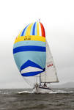
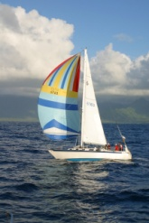
Great racing isn’t just confined to San Francisco Bay. Kit Wiegman has raced many Offshore races, including winning the Drakes Bay race (OYRA), Half Moon Bay race (SSS) double handed Farallon's (BAMA), and ZYC singlehanded Lightship Race. Then add his three races to Hawaii aboard his I-36 Cassiopeia in 2006, 2012 (2nd place in class) and 2016 (3rd place in class). In all of the races Cassiopeia was the slowest rated boat in its class! At left, Cassiopeia finishing in Hawaii, at right Lightship race.

In 2014 Steve Hodges won the Single Handed TransPacific race from San Francisco Bay to Hanalei Bay, Kauai, Hawaii with his I-36 Frolic. Steve won the Hanalei Yacht Club Trophy as the overall winner, and also won the Jim Tallet Memorial Trophy for first on corrected time on a yacht from outside Northern California (Frolic hails from Santa Barbara), and the Displacement Monohull Trophy for first on elapsed time in a heavier monohull.

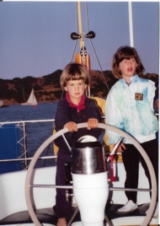
The I-36 is not only a great racing boat it is also a great family boat. Here’s a reflection from Jim Robinson, Pilot. “We purchased PILOT in the Spring of 1990 and started racing her in 1992. We bought her from a family in Moro Bay that had kids the same age as ours at the time, which was two and four. They were selling her because they thought it was too dangerous to have kids aboard, we were buying her because we believed it to be one of the safest boats around to raise kids on. Both Molly and Woody, at right, crewed for us until they went off to college.”

“I remember how open and welcoming everyone was. Don Schumacher, Rick Van Mell, Steve Schneider – all of you reached out and answered any question Martha and I had about how to race and rig the boat. We didn’t have a clue on how to race it – all of our experience was moving boats off shore. The racing and cruising fleet were the most remarkable group I’ve ever been associated with. They were, and continue to be, unbelievably inclusive and supportive. Steve was winning everything. He could go to weather 5 degrees higher than almost everyone. He told me years later it was because he used a smaller jib – who would have thought right?

“The first few years we finished so far behind the fleet that we had no idea who was coming in first. We knew for certain who was last. By the end of our run of winning I remember one race in the Berkeley Circle where we misread the race instructions and sailed the wrong course. The entire fleet except for the last couple of boats followed us. All were disqualified except those last two boats – it was good for their egos”

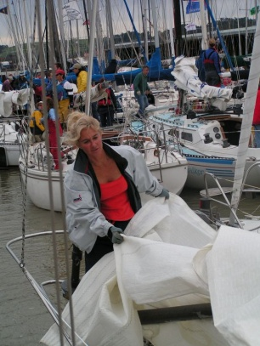
Jim modestly doesn’t mention that they went on to win the Hammond, Non-Spinnaker Trophy seven years in a row from 1994 through 2000. Jim quipped at one winners dinner, “We had to keep winning or Martha would have made me repaint the wall where it hung.” At right Martha is folding the jib at the end of the Vallejo race in 2005. Jim continues, …

“When we were racing hard (after Absolute dropped away) it was almost always Tom Cat with Barry Stomp along with the green boat Tenacious and Windwalker that were always around us. Once Peter Szasz showed up with Midnight Sun we were toast. Peter was a wizard and that boat was just too quick to keep up with. I do remember one year that at the annual meeting I had kept track of the times of the fleet in regards to the difference between the first and tenth boat in times on the water. When all the races were added up the finishing times between first and tenth was less than a couple of minutes. I’m not sure, but I think we were getting 8 to 12 boats on the line on a regular basis I think and the fleet was very competitive.”

This kind of learning and fun continued with the likes of Daphne Jackson’s Nimbus (who married Mike Dickson who crewed for her ) and Tim Shea’s Lean Times fighting for the “Smack Cup” for trash talking each other and trying to stay out of last place. And When Peter Szasz, Midnight Sun, started up the Race Clinics in 2004 he encouraged lots of sharing of lessons learned. Some of the best were Don Knox’s, Luna Sea, “View from the Rear,” and you can get a feeling for his writing style in the 5-17-08 Saga of Luna Sea. You can lose yourself for a whole winter day following the Racers' Clinics and Racers' Lessons links.

In 2005, Kimball Livingston noted, “On San Francisco Bay, the Islander 36 fleet "de-turboed" in order to get more boats out racing. Islander 36s have been a fixture since Alan Gurney designed them in the 1970's - Northern California alone has more than 150 of them - but the racing fleet dwindled as people with the skill sets to handle spinnakers in a big breeze moved on to newer, hotter boats. Eliminating spinnakers and big jibs was a shot in the arm for the fleet last year. Twenty boats turned out for the 2004 season opener, the Vallejo Race, making Islander 36s the biggest one design fleet in the event.”

Always looking to promote the I-36, 2004 Commodore Harry Farrell encouraged Kimball to give the fleet more publicity. His tart reply was, “Show me the Bacon.” With help from wife Carol Williams, and Carol’s Daughter Michele Williams, (who became the first female I-36 Commodore in 2010 – we believe in diversity) I-36ers responded in force!

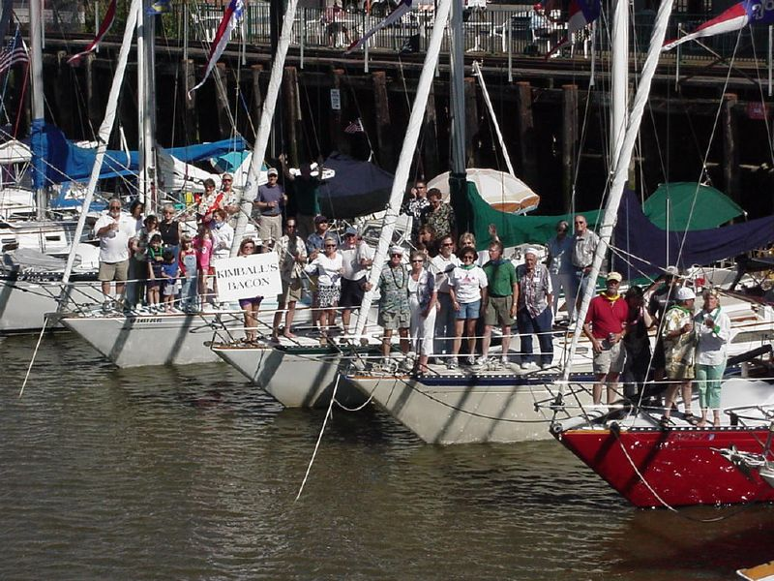
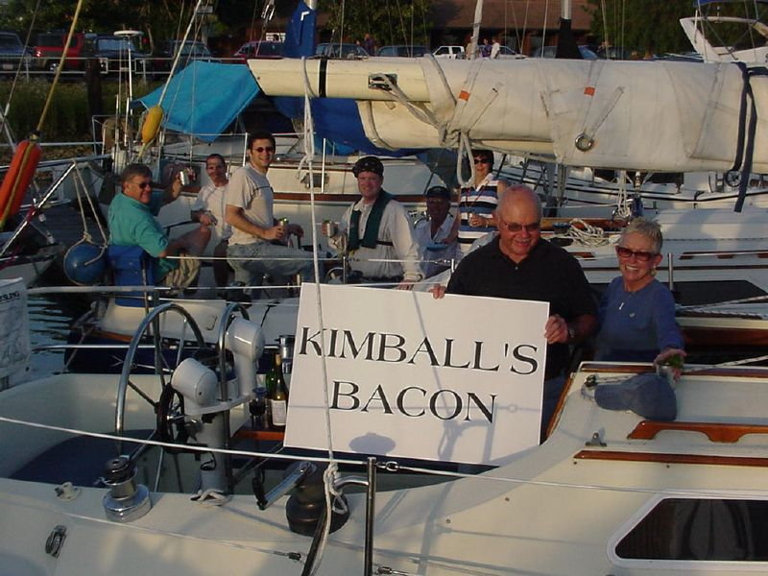
2004 Vallejo Race - Pacific High / Blue Streak 2004 Petaluma - 21 Islanders Represented
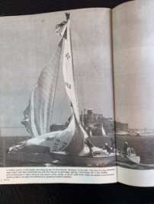
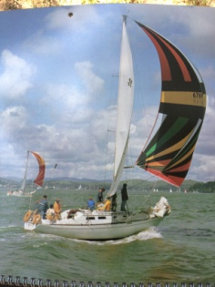
And speaking of publicity, Lou Zevanov sent us photographer Diane Beason’s picture on the left of Diana in the late 70’s which she used as the cover photo for a 1980 calendar. Mike Fitz-Gerald send us another of Diane’s pictures showing Shenanigan’s blown chute with Alcatraz Island in the background

Again in the interest of promoting participation, in 2003 we added a “Nationals Regatta” at the end of the season. It was not counted as part of the Season’s Championship, but an event to get out both the dedicated racer and the occasional racer or even cruiser who wanted to try racing. Raced most years from GGYC, there were no entry fees and just Islanders out racing so no crowds of boats. The regatta is was topped off with a “Nibbles & Celebration” buffet at GGYC where sea stories could be told and crews could mingle. It has proved to be very popular, and continues to date. Fun examples of the fun, including John Melton’s Freedom Won crew in their I36 logo jackets.
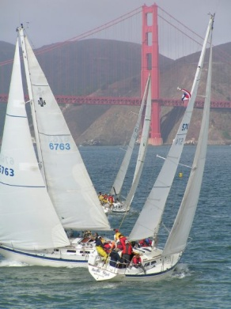
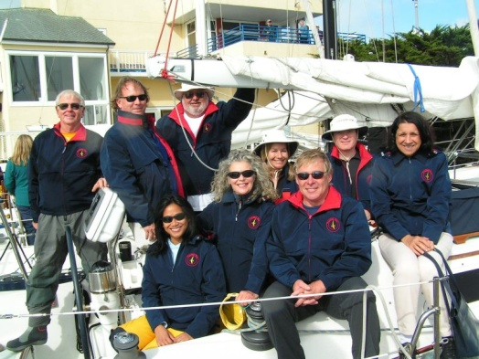
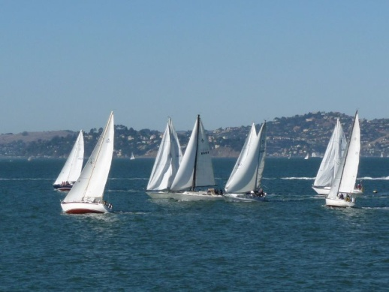
2014 2nd Race Start 2008 Crossing the Gate 2008 Freedom Won crew

And yes, over the years as boats and people aged, cruising became more popular. Islanders happily took to holding weekend rendezvous at harbors and yacht clubs around the Bay, into the Delta, and outside the Gate. Since 1998 the fleet has tallied up 170 cruises to over 30 ports, or, counting our Spring and Fall Meetings, about 7 – 8 per year. Some were casual affairs with 3 or 4 boats, others had themes and pushed 20 boats like the Petaluma cruise pictured above. Ports included Petaluma, Napa, Benicia, Vallejo, and even Stockton at the end of Delta cruises. Yacht clubs included St. Francis, San Francisco, Golden Gate, Oakland, Encinal, Coyote Point, Sequoia, Marin, Pt. San Pablo, Presidio, Island, Balena Bay, Sausalito, and, before it silted in, San Leandro.

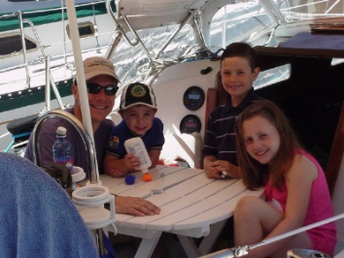
Cruising was also family friendly. Founding member Lou Zevanov’s son Steve adds his memories aboard Diana. “I was 11 years old (when Lou bought her). Diana was a major part of our family life for about 15 years. In the mid-80’s, my folks sold her and moved on to a 41 foot motor sailer. After I finished college in early 80’s, I raced on various types of boats in the ocean and on the bay. However, in 2002, Dad found Diana in Moss Landing and decided to repurchase her. So, I sold my Cal 29 and we started using the Islander as the family boat. Of course, before we knew it, the competitive juices emerged and we started racing with the fleet again.” At right, Steve and his kids aboard Diana on a Petaluma cruise in 2004.

Skipper & Nancy Wall, among the first to retire, often sailed Snowflower to the cruise destination on Friday evenings, to be joined by the rest of the still-working cruisers on Saturday. If our destination was a yacht club, we would usually support their bar and food service at least one day of our cruises. If that was not available, we were great at pulling off potlucks on the dock.

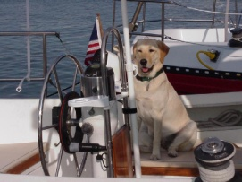
Kids and dogs were also welcome. In the canine corps there were Cathy aboard Gary & Pat Salvo’s Ophira, (right) and Max & Riley aboard John & Nanci Melton’s Freedom Won. Dennis & Judy Bush had Tucker so well trained that they could tell him to “go back to the boat” and away he would run and jump aboard Natural High. Teak, and occasionally Peach the Cat, staffed the quarterdeck aboard Vanishing Animal for Rick & Sandy Van Mell. All were friendly and joined in the festivities when the fleet gathered for a cruise.

And just like the racers, cruising Islanders ventured out the Gate to Drakes Bay and Half Moon Bay, and many places beyond. Brian Jacobs sailed Blue Moon down the coast and back in 2000 and wrote a great article about the trip. One of the fun things about this story is that it’s written with Brian’s view, and his wife Fran’s view. Not surprising, but delightfully candid. Cruising the CA Coast

Yes, Blue Moon is an Islander Freeport 36, the comfortable, cruising version of the I-36 racer. We definitely believe in diversity – and besides, Freeports are great boats to host cocktail hour too. Smoke & Laurie Stover liked going fast in their I-36 Solace, but like to cruise in their Freeport 36 Evanescence! Rich & Takae Watters sailed Tacoma Blue left out the Gate to San Diego, then had her trucked to Mobile before finally taking up residence on Tampa Bay where the weather is warmer and the winds are lighter.

Several, including Noble Brown’s Mai Pen Rai and John Melton’s Freedom Won headed south for the Baja Ha Ha. And even if Islander folks didn’t take their own boats down, they managed to fly the burgee as crew. In 2005 Ken Wilson was aboard Laurelai and Chris Mellor/Kelley Montana aboard Sensei (that's the Norsemann 447 that grew from their I-36 Spindrift). Crew on Sensei included Smokey Stover (Evanescence F-36) and Tim Shea (Lean Times). Joe and Sandy Vanni, the owners of Zephyrus, I-36 berthed in Ventura, crewed on a Catalina to Cabo then on to the mainland. In addition Barry Stompe and Sylvia Stompe (Tom Cat) were aboard the catamaran Profligate and took the pictures below. Thus at least six Association boats were represented this year. Baja Ha Ha Reports

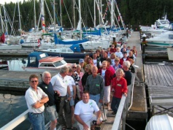
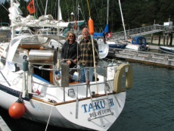
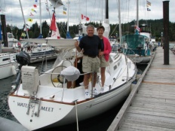
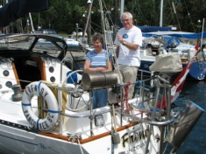
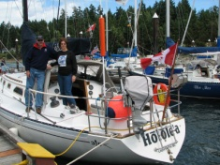
But up north there’s an equally hearty branch of the Islander 36 Association members in the Gulf Islands of Canada. It mostly started with Bert Vermeer and his Bahama Islander 30. (Yep, there’s our diversity is on display again.) Bert & Carey set a new standard of excellence in Islander rendezvous with the First Canadian All Islander Rendezvous at Telegraph Harbor Marina on Thetis Island, July 9-10, 2005. From the beautiful event logo, information pages for each boat, stick-on decal mementos and terrific organization, Bert & Carey made it look easy. We still don't know how they managed to squeeze all the goodies aboard Natasha: the 60 pounds of charcoal, piles of potatoes, bushels of salad makings, all the great signs, and still kept two big, decorated cakes perfect right to the table. There were 16 boats in total, including an I-28, an I-29, 8 I-30s of three different types, an I-34 ketch, and 4 I-36s. Here’s a montage of some of the fleet. The web page: 7-9-05 1st Canadian Rendezvous
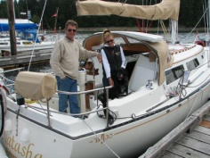
I-30 Natasha I-36 Holole’a I-36 Fendy I-36 Waters Meet I-36 Taku II Everyone!

There were a total of 7 Canadian All Islander rendezvous stretching through 2014. They were so successful we copied the idea and held 5 of our own between 2007 and 2012, several with over 20 boats on the water and another dozen represented by folks arriving by car.

Bert has almost single-handedly given us a complete cruising guide to cruising around Vancouver Island with his many presentations at meetings and numerous, detailed logs of his cruises aboard Natasha. Whether it’s just showing us the rich harbors of the Gulf Islands, the wonders of Princess Louisa Inlet, the majesty of Desolation Sound, or the awesome and sometimes frightening splendor of circumnavigating Vancouver Island, Bert brings cruising to life for all of us.

And if Canada isn’t far enough for an I-36, cruisers like David Book sailed his I-36 Hangover to Hawaii just for fun. Not only did he live to tell the tale, but David had our full attention and plenty of laughs and smiles at our 2019 Fall Meeting as he described his odyssey from a starter boat that went aground in Half Moon Bay, through an intermediary boat, then on to (as the salesman told him) "The World's Fastest Production Boat!" He had long dreamed of sailing to Hawaii - how much fun, and how hard could it be? So, with encouragement from his daughter Paige he stopped procrastinating and made the move. Though he and Paige have sailed for their lifetimes, Yann was a newcomer to sailing, and the 4th crew member sailed for the first time barely weeks before they departed. With some weather routing by text message from a friend in Tasmania (no less!), they caught a strong northwester as they departed Monterey and after the first six hours were making 9 knots! 24 hours later they were off Los Angeles, and 2 days out had crossed the latitude of Mexico. Despite advice to stay left and hang on south, the urge to turn right and aim at Hawaii won out. Two days later they were enjoying swimming off the boat in a dead calm. Lots of fresh food, rain squalls, periods of surfing seas, and 21 days out they arrived in Honolulu.

And speaking of Tasmania, the Association is proud to have as members George & Rowena Auchterlonie, members of the Royal Hobart Yacht Club in Tasmania, Australia, who keep their I-36 Sorceress in Hobart. Then throw in two members from the UK and 5 more in Canada. Top it off with member Andrew Vic whose I-36 Geja is berthed on the Croatian coast of the Med and spends summers inviting women and men to be his crew each summer (though he lives in San Francisco.) That leaves the other 121 active members spread across 25 states almost seasick with envy. Just under half, 53 are from the Bay Area, with 14 more in southern California, totaling 67 in California. There are 6 in Washington, 5 each in Oregon and Texas, and 3 in (very dry) Arizona!

Though we only have membership lists from the late 1990's, sorting through 15 samples about every other year, we have learned that, of the original 770 boats built, at least an astonishing 556 unique boat names have been members of the Association, and when counting up boats that have been owned by multiple owners, we have had a whopping 697 unique boat-owner listings. We're woefully short on data from our founding in 1974 through at least 1990, so if you have any old fleet lists, please send them along! Here's a link to the spreadsheet with the select year fleet lists, and on the second tab, the sorted list which shows how many times a boat appeared in the various lists and the list of unique boat-owner names. Boat Names By Year. When we shared this with our members, many came back with their memories of names and events, too long to list here, but one shows the simple respect for the pedigree and the honor in a name. This from past member Brigadier General Brad Owens of the South Carolina National Guard Command Staff, “ “Calandra" owned by the Poulus' was bought by us, we changed the name to "At Ease". Both are listed on your spread sheet. "At Ease" has recently been sold and is now owned by Leslie (last name?).” Editors note: What a perfect name for an I-36 owned by a General!

Finally, there is everything current and so much more history on the Islander 36 Association web site: www.islander36.org . There are 537 individual pages to scan, with over 26,000 pictures from great sailing to rigging your boat for comfort and speed, winning races, to fixing stuff, how to train your skipper, or living the life of cruising from Canada to Maine to the Med.

Over the years some of our members asked why we make all of this freely available to the whole world on our web site – isn’t it worth more than that? Well, the answer seems to be that time and again people join up just because they see so much value in what we post and share. The critical thing about membership is that you get on the joint email list of 129 other Islander owners to ask your questions and share your ideas. We’ve walked the docks and know there are lots of I-36s that aren’t currently members, but they are certainly welcome to join and share their great “sea stories” with the rest of the fleet.

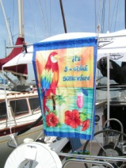
So if you can’t get links from this page or article, go the web page, sit back with your favorite sundowner, and soak up the joy of Islander owners around the world. As Skipper Wall said repeatedly aboard Snowflower, “Somewhere in the world it’s 5 o’clock.” (And had the banner to prove it!)

