The Islander 36 Association
Of San Francisco Bay

To all who shall see these presents, Greetings:
Know ye, that reposing special trust and confidence in the experience and abilities of
Thomas “Skipper” Wall
who has provided many years of dedication and contributions to,
and maintained continuing love and esteem for the,

Islander 36 Association of San Francisco Bay
The Governing Board does herewith appoint him an
Honorary Member
Know ye friends and sailors everywhere that the aforementioned member is entitled to all the privileges of Islander sailors afloat, and I do strictly charge and require all of them to heed his counsel and advice, knowing that he will diligently keep the best interests of the Association at heart.
Done by the Governing board on the 23rd day of February, in the year
Two Thousand Fourteen.

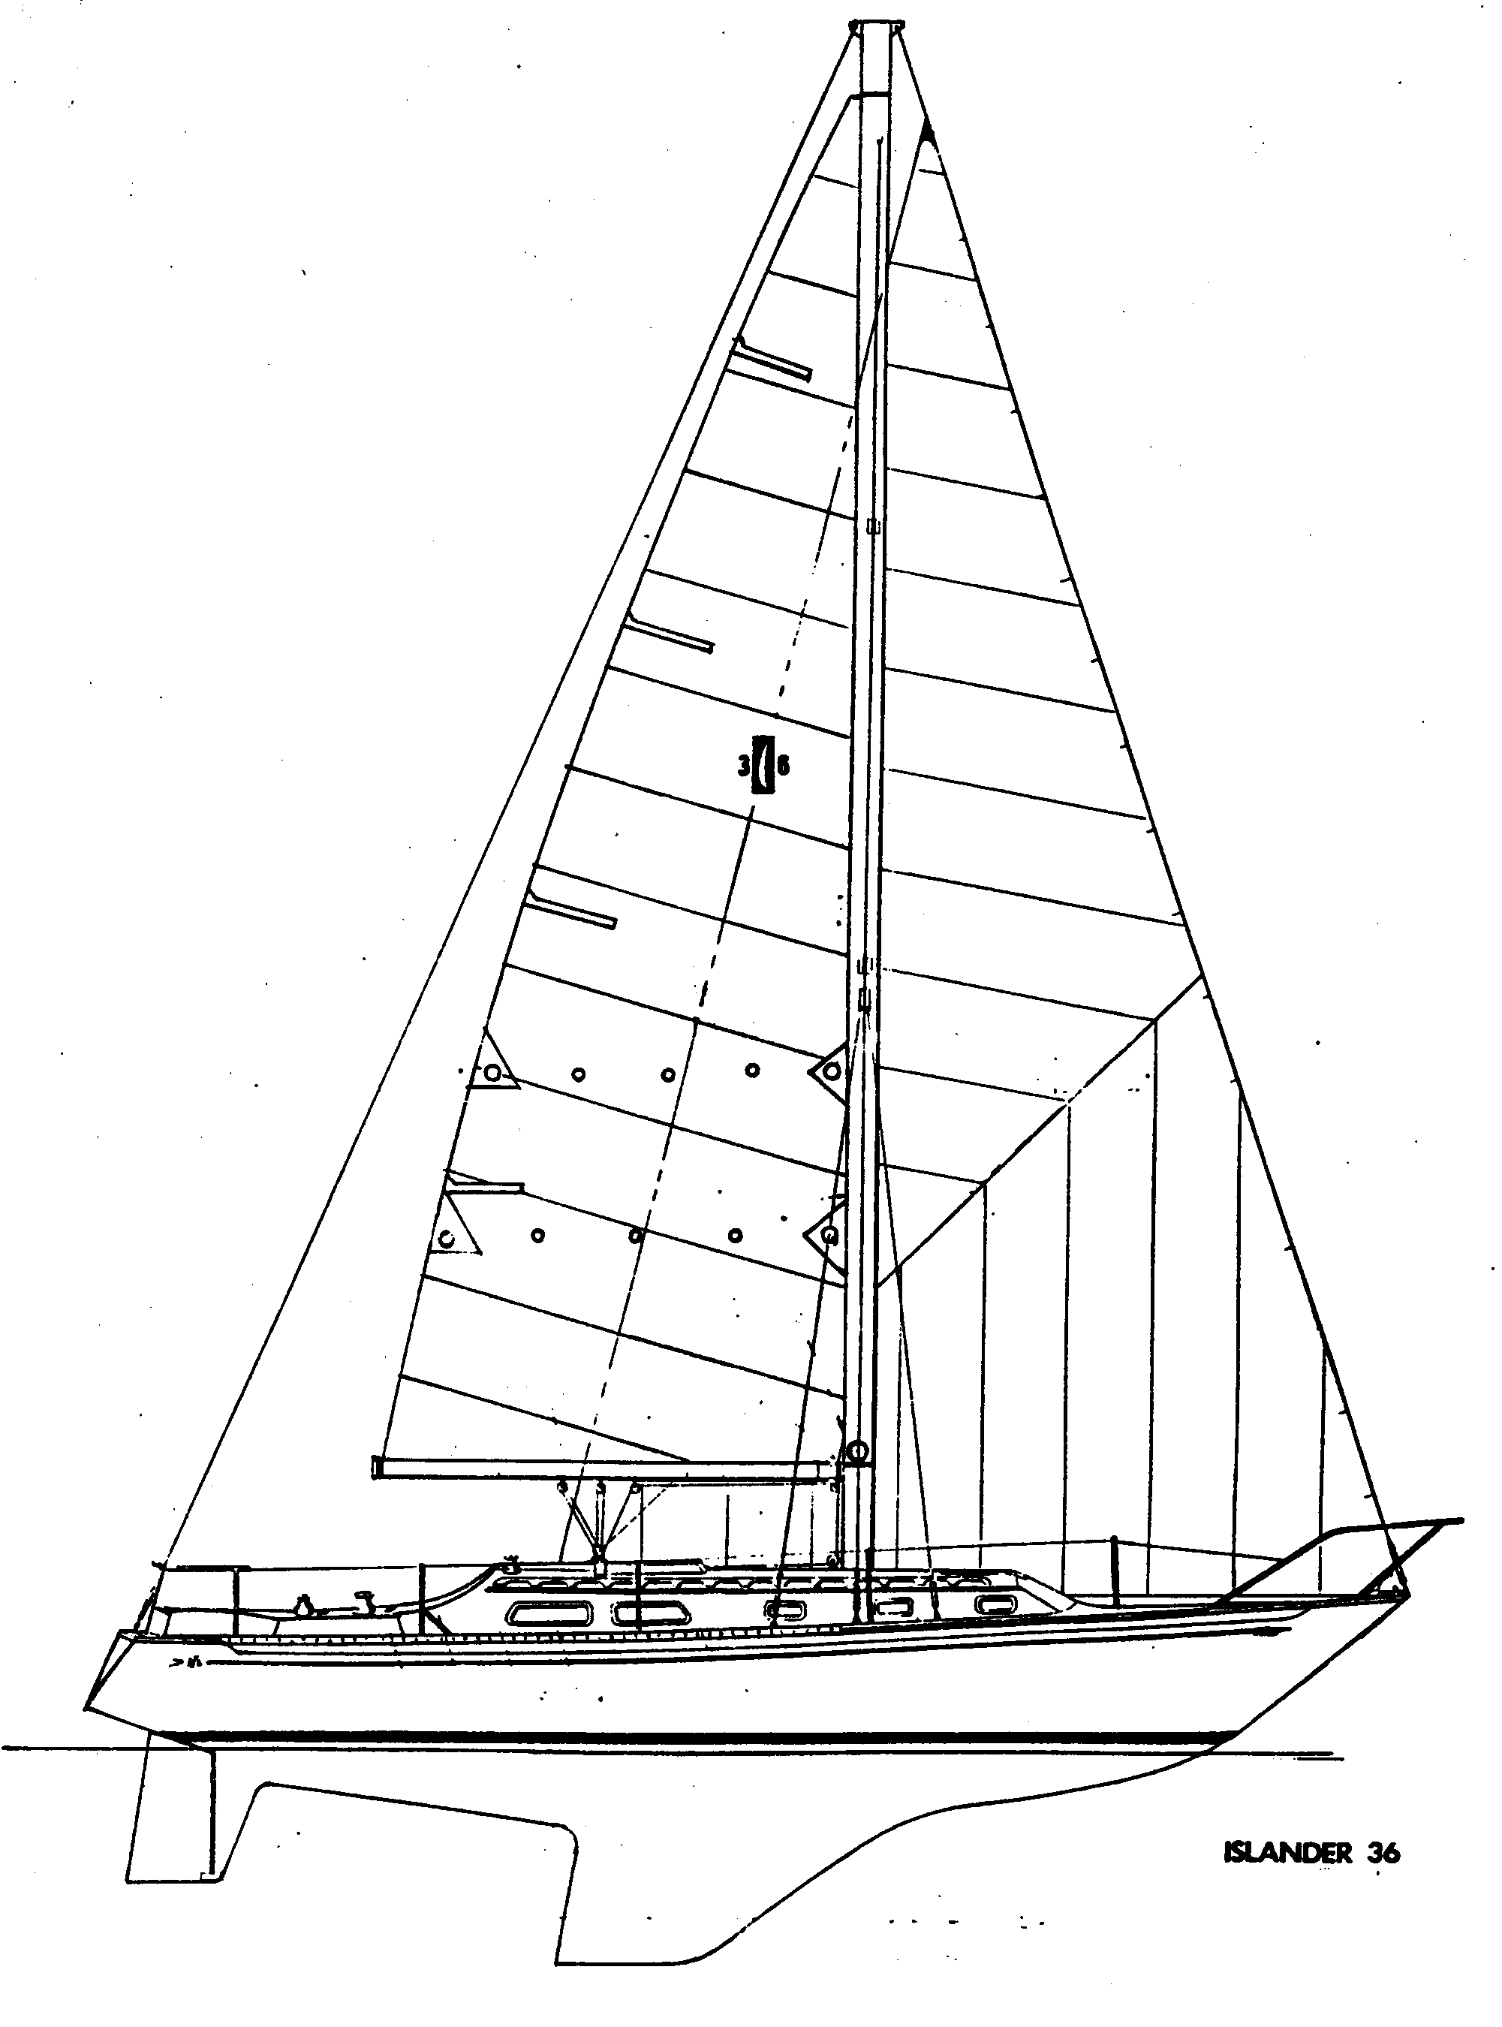
____________________________________
Richard Van Mell, Commodore

