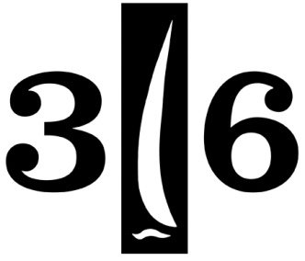
The Islander 36 Association
Of San Francisco Bay

To all who shall see these presents, Greetings:
Know ye, that reposing special trust and confidence in the experience and abilities of
Art & Betsy Fowler
who have provided many years of dedication and contributions to,
and maintained continuing love and esteem for the,

Islander 36 Association of San Francisco Bay
The Governing Board does herewith appoint them
Honorary Members
Know ye friends and sailors everywhere that the aforementioned members are entitled to all the privileges of Islander sailors afloat, and I do strictly charge and require all of them to heed their counsel and advice, knowing that they will diligently keep the best interests of the Association at heart.
Done by the Governing board on the 21st day of March, in the year
Two Thousand Fifteen.

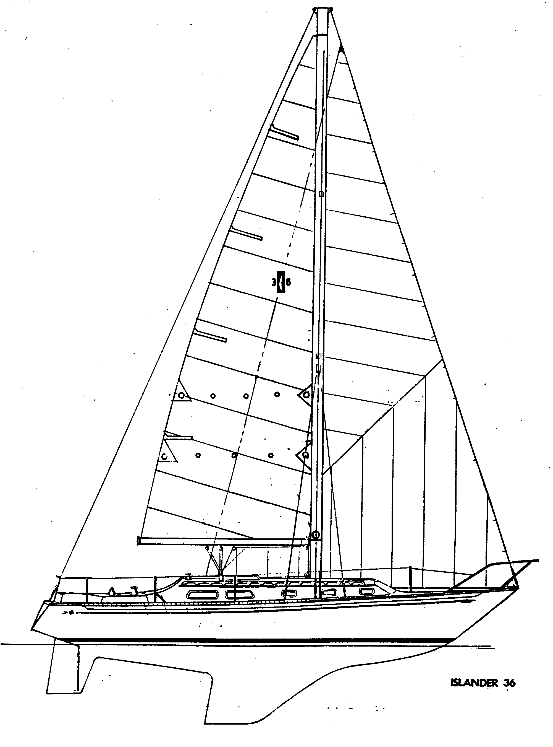
____________________________________
Richard Van Mell, Commodore

